**DIGITAL LOGIC DESIGN**

**PROJECT REPORT**



|  |  |
| --- | --- |
| Group Members Name & Reg # | Muhammad Haris Irfan | Sana Elahi  **FA18-BCE-054**  **FA18-BCE-090** |
|  |  |
| Class | Digital Logic Design CPE241 (**BCE-2B**) |
| Instructor’s Name | Sir Muhammad Imran Saeed Lodhi |

**Line Following Robot**

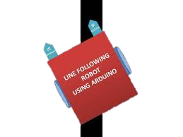

**What is a Line Following Robot?**

Line following robot can detect bright light using sensors and it defines its motion accordingly, after sensing the line it maneuvers to stay on course while correcting wrong moves, It will be a robot that will basically follow the path determined by the user, the path maybe as simple as a straight or a curved line or it may be as complex as a 90 degree turn.

The line follower robot built in this project is divided in to 4 blocks. The following image shows the block diagram for line follower robot.

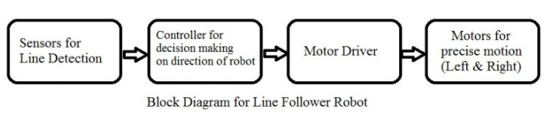

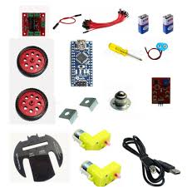**Components Used**

* 1Pc Motor Driver
* 1 Pc ARDUINO Controller Board
* 5 Pc line tracking module.
* 4 Pc Motor
* 4 Pc wheels
* Power Supplies
* 1 Pc Robot Chassis
* Connecting Wires
* Sensor Shield or Bread Board
* HC-06 Bluetooth Module (Optional)
* Laptop for connection during programing/ testing

**High Level Diagram**

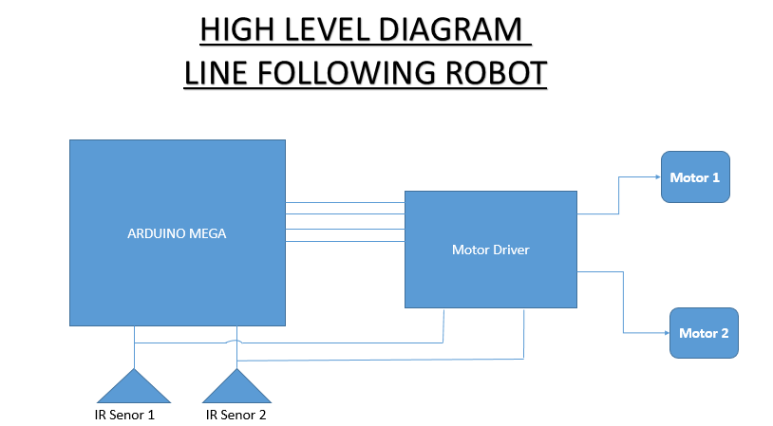

Figure: 1

**Working Principle of our Project:**

In this project, we will develop an Arduino based Line Follower Robot. It will detect the black line on the surface and move along that line. The working has been explained in the succeeding paragraph.

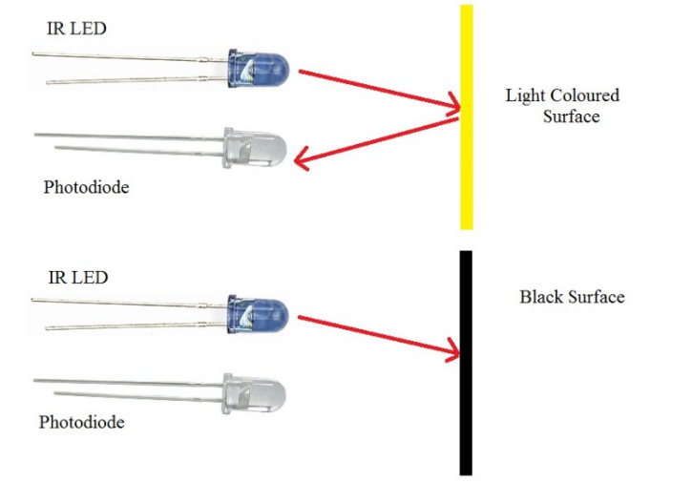 A programmable Arduino device will be used along with a motor driver for connecting motor and sensor for line detection and movement control. Two IR Sensors for right and left will be used in both receive/ transmit mode (IR LED and Photo Diode). Sensors will be placed in a reflective way i.e. side – by – side so that whenever they will come in to proximity of a reflective surface, the light emitted by IR LED will be detected by Photo diode.

**Figure 2** shows the working of a typical IR Sensor (IR LED – Photodiode pair) in front of a light colored surface and a black surface. As the reflectance of the light colored surface is high, the infrared light emitted by IR LED will be maximum reflected and will be detected by the Photodiode. In case of black surface, which has a low reflectance, the light gets completely absorbed by the black surface and doesn’t reach the photodiode.

Figure: 2

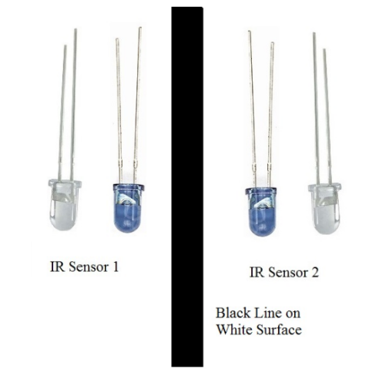Using the same principle, we will setup the IR Sensors on the Line Follower Robot such that the two IR Sensors are on the either side of the black line on the floor.

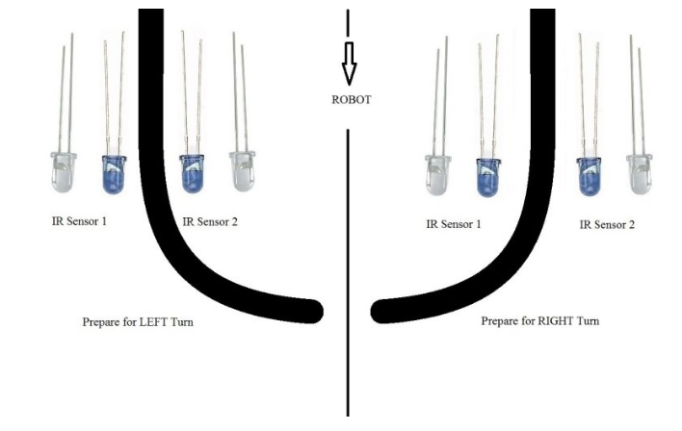When the robot moves forward, both the sensors wait for the line to be detected. For example, if the IR Sensor 1 in the above image detects the black line, it means that there is a right curve (or turn) ahead.

Figure: 3

Arduino MEGA detects this change and sends signal to motor driver accordingly. In order to turn right, the motor on the right side of the robot is slowed down using PWM (Pulse Width Modulation), while the motor on the left side is run at normal speed.

Figure: 4

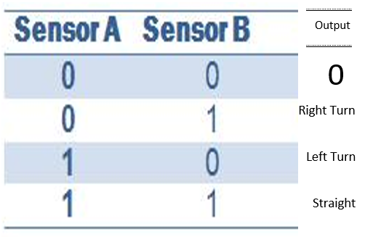**Truth Table**

**Line following Robot- An advancement of technology!**

The line following Robot is basically an advanced automated mobile operator which is being successfully used in many industrial and public fields to aid the work burden as it requires no human operating and can perform repetitive tasks following its assigned trajectory path with supervision, thus making manual work easier for humans in this era of rapid, demanding and progressive lifestyle.

**Final Comments:**

* **Comments by Haris Irfan.**

**Inko paraphrase krlo**

* **Great learning experience**
* **Can easily make any circuit board now**
* **Learned solding**
* **Learned schematic**
* **Designing a pcb**

*THANK YOU!*

**THE END**